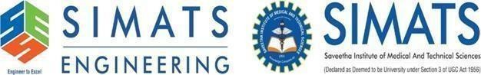

Course Name: Mobile Computing for Modern App Development
Course Code: ITA0306

Q: CORE VIDEO FRAMEWORK

